Crime Mapping
Name
Institution
Date

Crime Mapping
Crime Mapping Map of California.
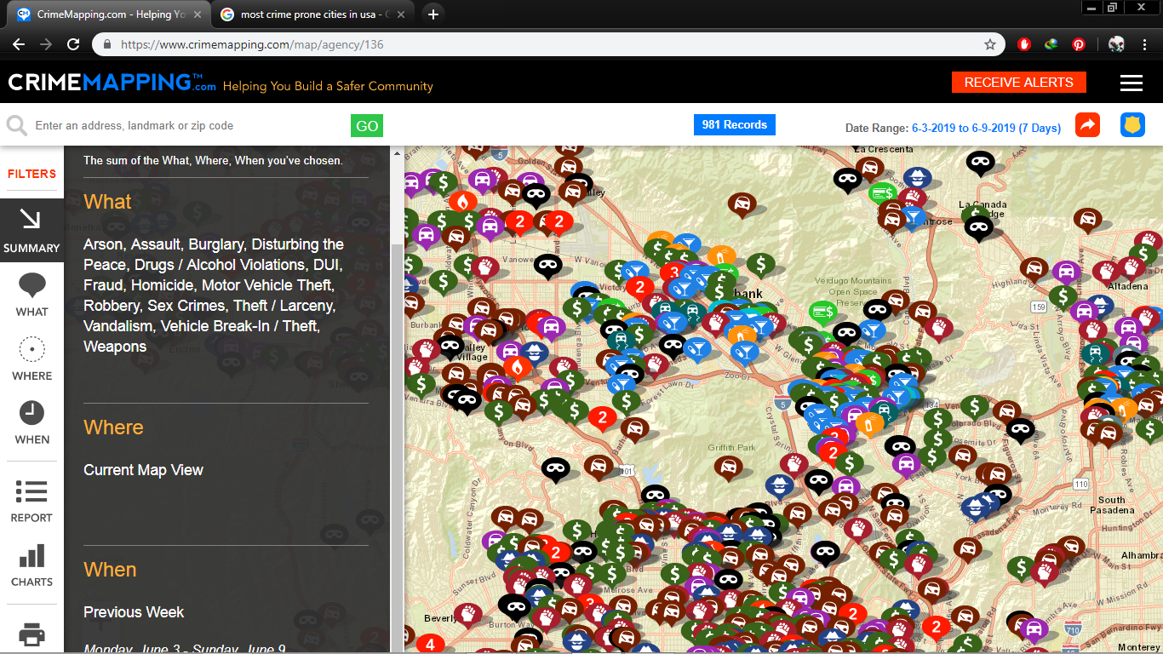
According to the Bureau of Justice Statistics (2018), California is ranked among the top ten most crime-prone cities in the USA, and as such, this is the city of focus in this task. Although crime is on a downward trend, the number of criminal cases reported to the Glendale police station remained high. The category of crimes reported varied depending on regions and time of the year across the city.
Information from the crime mapping software indicates that some of the most common crimes in California include vandalism, drugs/alcohol violations, and motor vehicle theft, with vandalism taking the lion's share. According to the Penal Code (2016), under the California law, vandalism is committed if an individual destroys property that they do not own or defaces property that they do not own using graffiti. Therefore, vandalism is a very serious crime in California, which is punishable by probation or even jail time in state prison. The other most common crime is the drug/alcohol violation. Although the state of California legalized possession of recreational marijuana, illegal sale or possession of large amounts of drugs is still a serious offense in the state. Alcohol is also legal, though only to persons over the age of 21years. However, individuals caught driving under the influence of alcohol are legible to punishment ranging from jail time to compulsory rehabilitation. Finally, the other serious crime in California was motor vehicle theft. According to the California penal code (2016), motor vehicle theft refers to the act of unlawfully taking of a motor vehicle belonging to someone else. This crime can be charged as a felony punishable by jail time or heavy fine or both.
The crime mapping software indicated that these crimes, for instance, vandalism, are mostly clustered around the densely populated areas. Similarly, alcohol and drugs violation crimes were seen to be grouped around the urban areas together with motor vehicle theft crimes. The crime mapping technology may be used by the law enforcement agencies in predicting which crimes are most likely to happen within a specific time frame and where they are most likely to happen. It can also be used to come up with statistical data showing whether crime is on the rise or drop and therefore form the basis of formulating crime tackling tactics. By indicating the areas where crimes mostly occur, the law enforcement department is able to formulate the most effective policies of curbing specific crimes and therefore increasing the chances of reducing such crimes.
In conclusion, this software can be seen as a valuable source of information which shows crime trends and the probability of different types of crime occurring. Therefore, it can be an important tool in the law enforcement department, which will help to prevent and control crime.

References
Bureau of Justice Statistics. (2018). Data collection: National Crime Victimization Survey (NCVS). Retrieved March 13, 2018, from https://www.bjs.gov/index.cfm?ty=dcdetail&iid=245
Snape, J. (2016). California Penal Code 2016 Book 1 of 2. Lulu. Com.
TriTech Software Systems. (2016). CrimeMapping. Retrieved from http://www.crimemapping.com

